***Docs for Hedy MCU (ESP8266 Microcontroller)***

**EasyEDA** is a web-based [EDA](https://en.wikipedia.org/wiki/Electronic_design_automation) tool suite that enables hardware engineers to design, simulate, share - publicly and privately - and discuss [schematics](https://en.wikipedia.org/wiki/Circuit_diagram), [simulations](https://en.wikipedia.org/wiki/Simulation) and [printed circuit boards](https://en.wikipedia.org/wiki/Printed_circuit_board). Other features include the creation of a [bill of materials](https://en.wikipedia.org/wiki/Bill_of_materials), [Gerber files](https://en.wikipedia.org/wiki/Gerber_format) and pick and place files and documentary outputs in PDF, PNG and SVG formats.

EasyEDA allows the creation and editing of schematic diagrams, [SPICE](https://en.wikipedia.org/wiki/SPICE) simulation of mixed analogue and digital circuits and the creation and editing of printed circuit board layouts and, optionally, the manufacture of printed circuit boards

**Schematiic dia:**

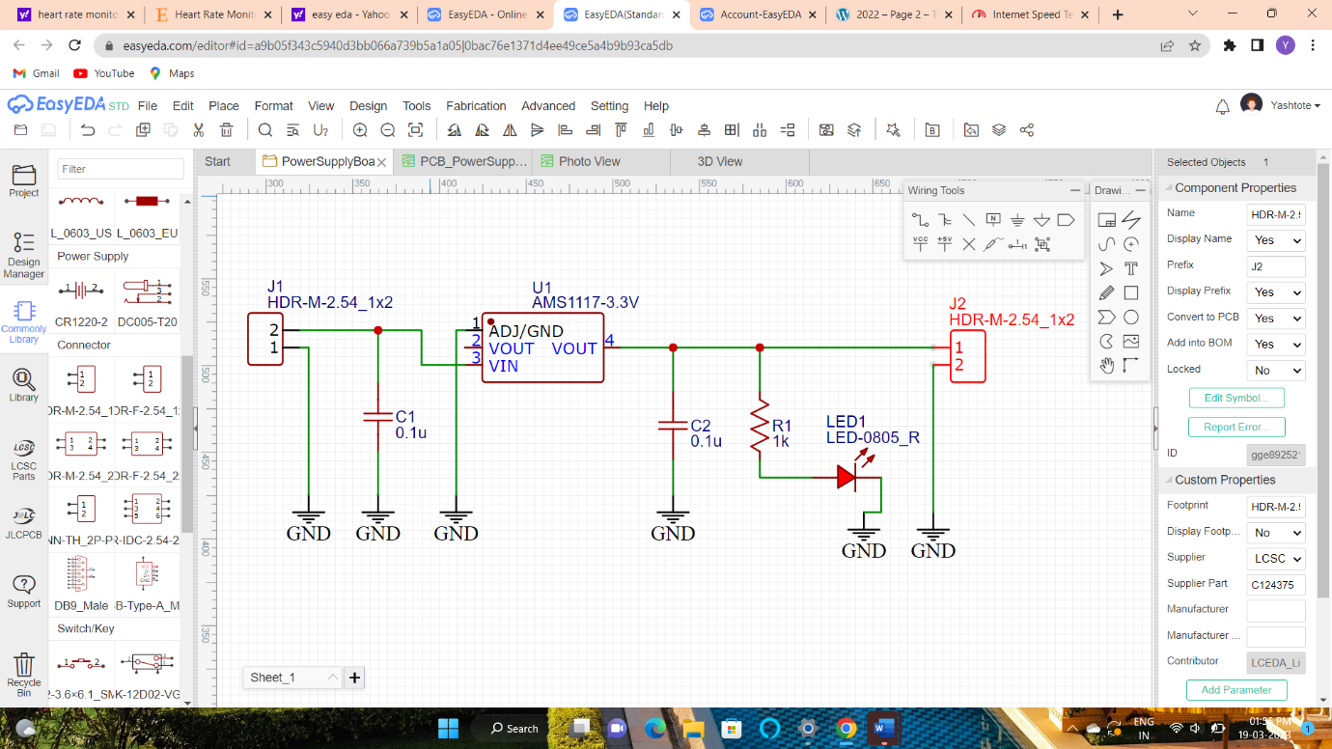

**Pcb dia:**

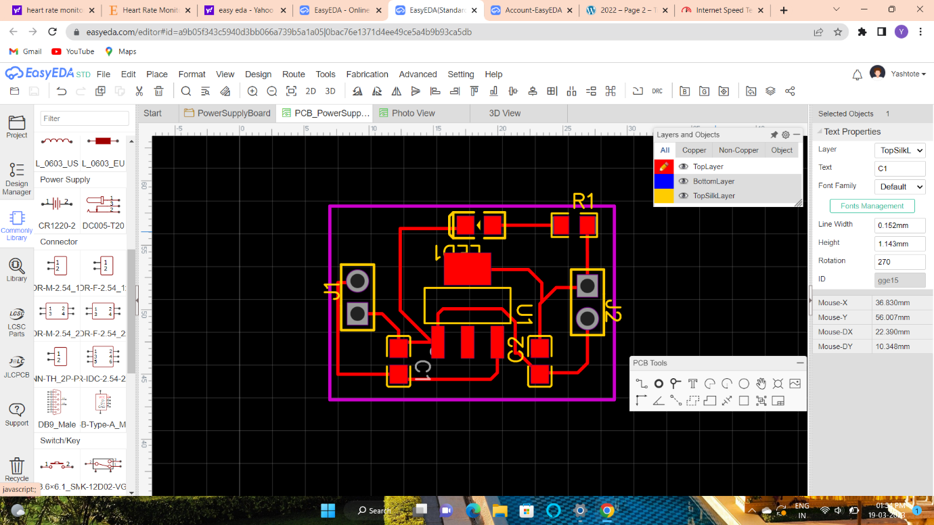

**2-D view:**

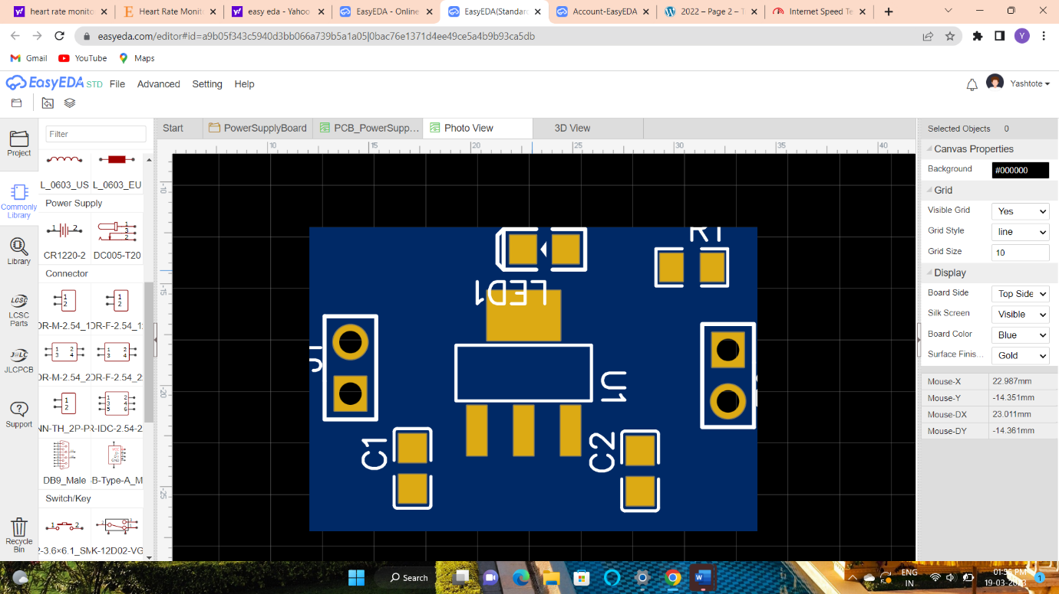

**3-d View:**

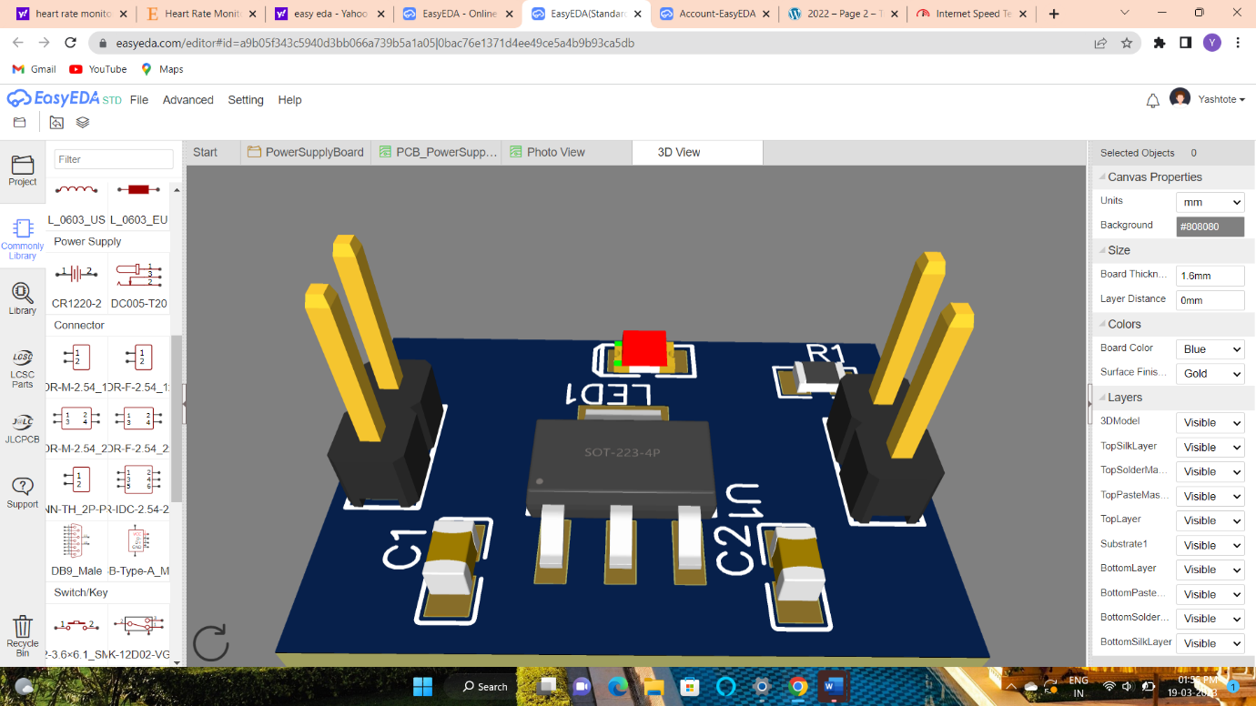

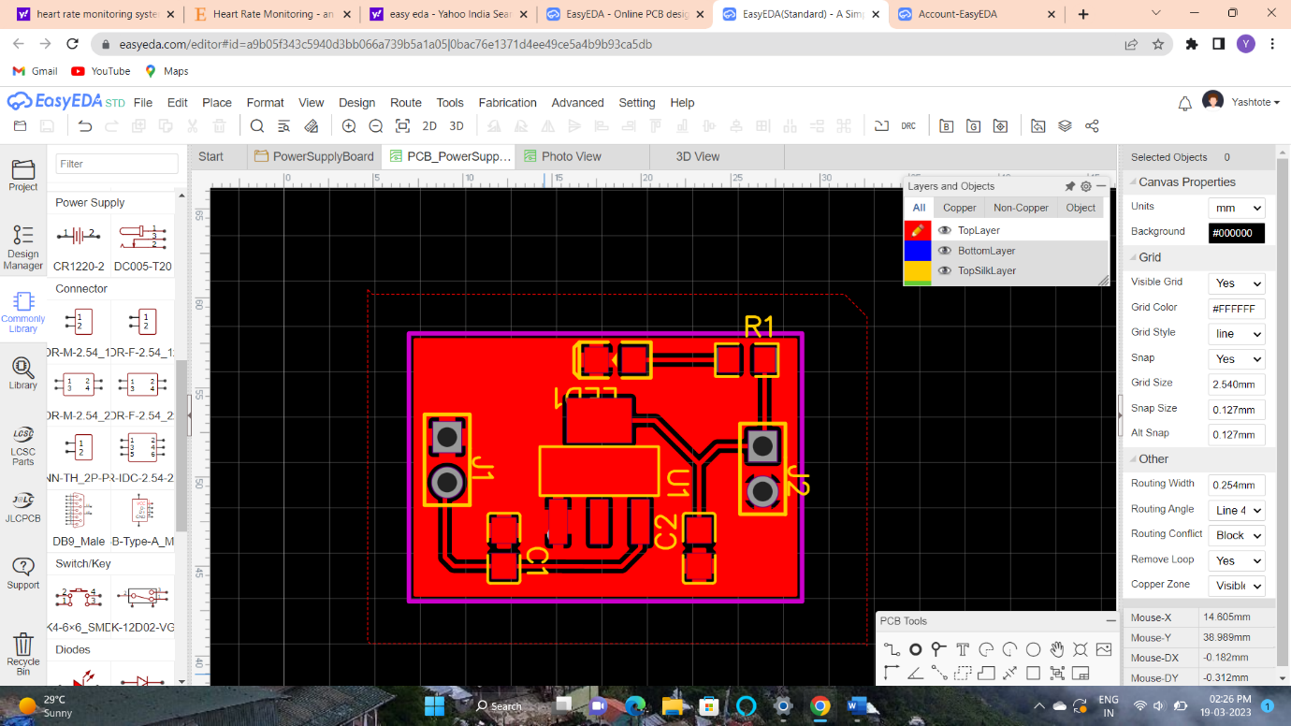

**After applying switch in schematic in input side**

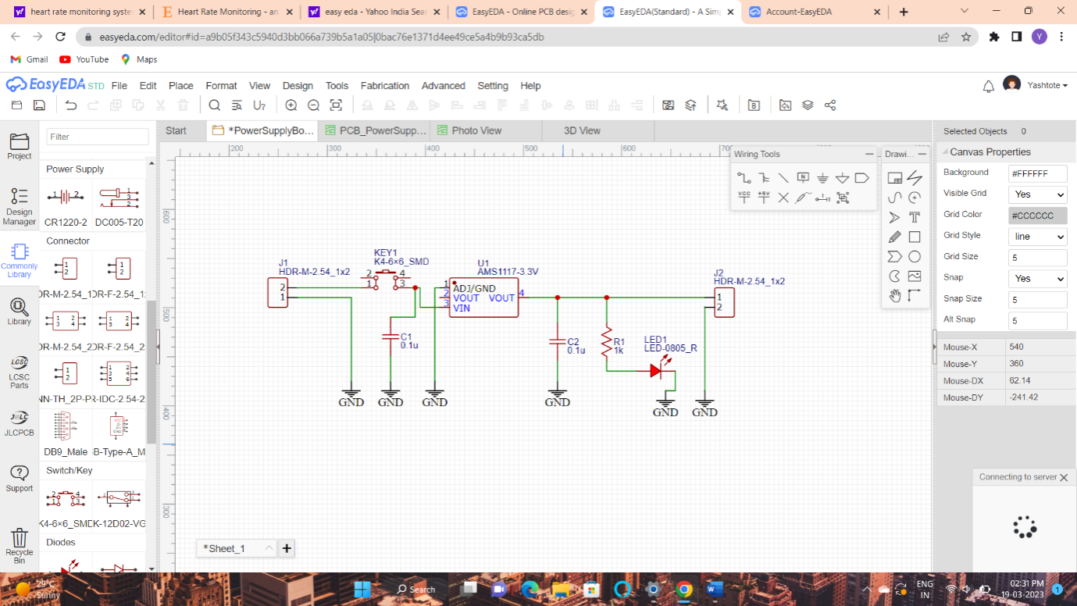

**Applying connections of blue lines without overlapping**

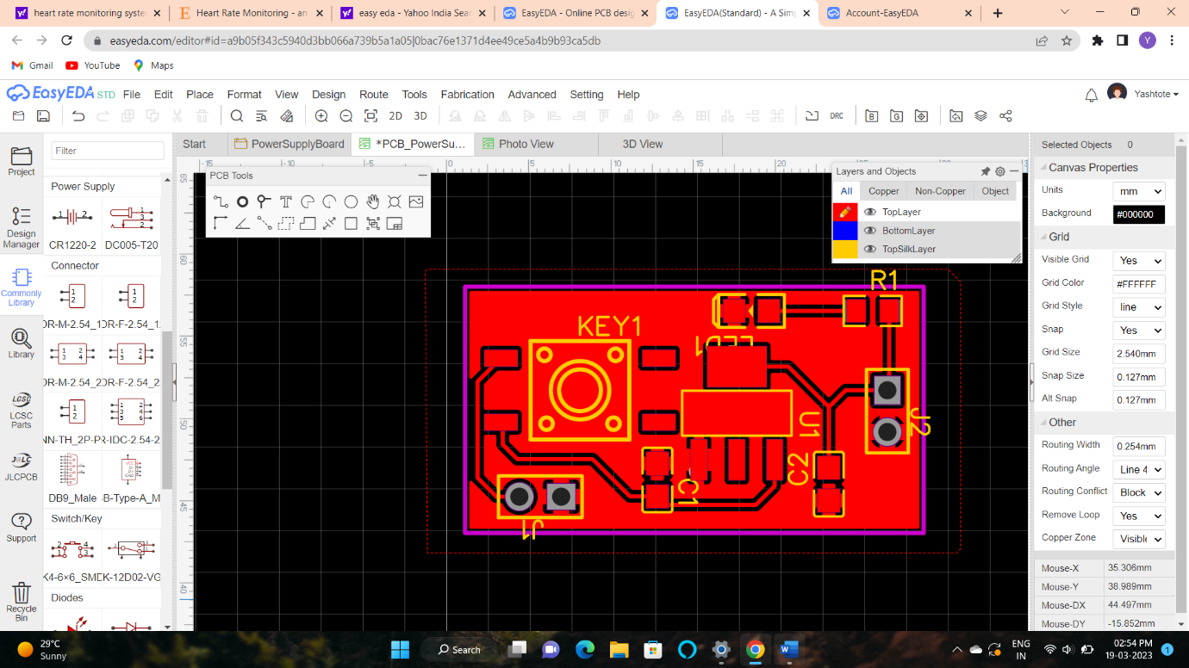

**2d view after switch**

A

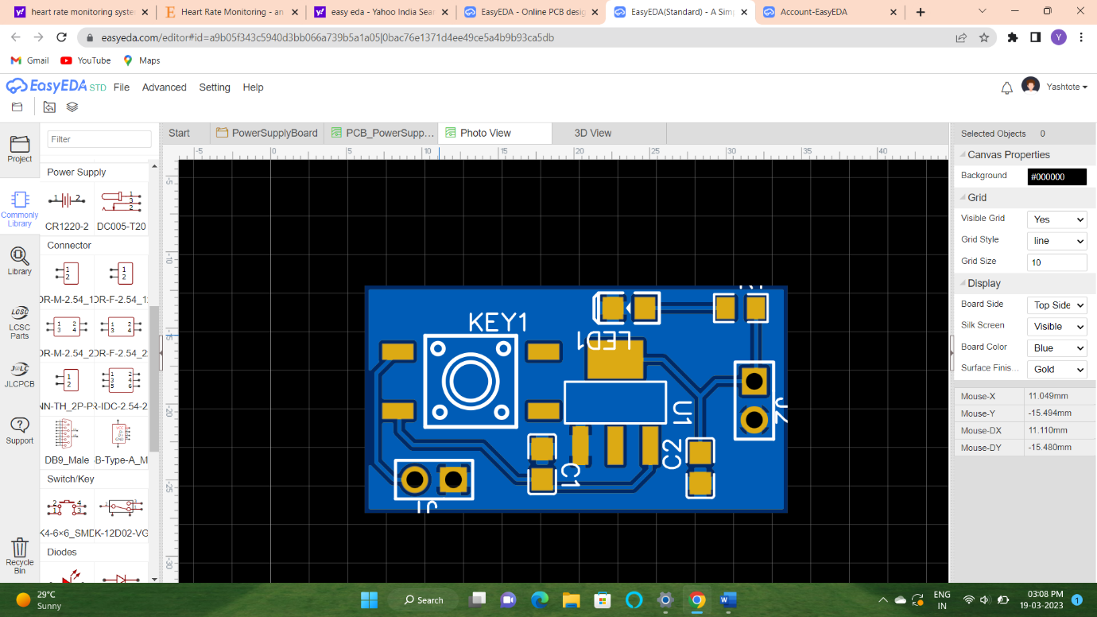

**3d view after switch**

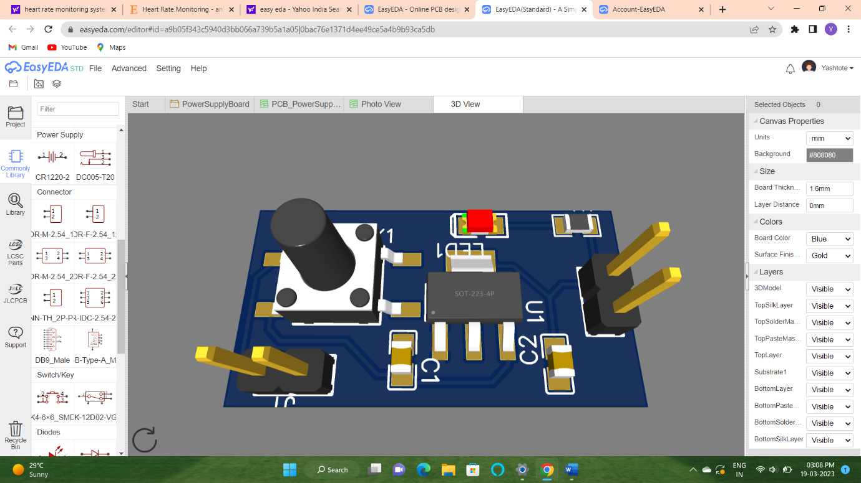

`**Using Via(v) :to connect upper layer with bottom layer**

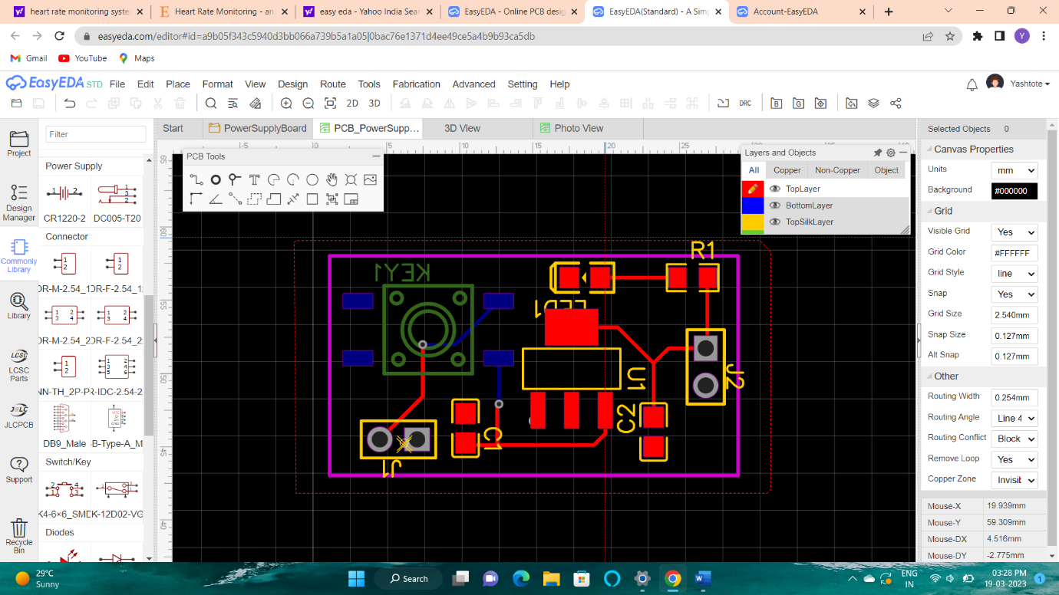

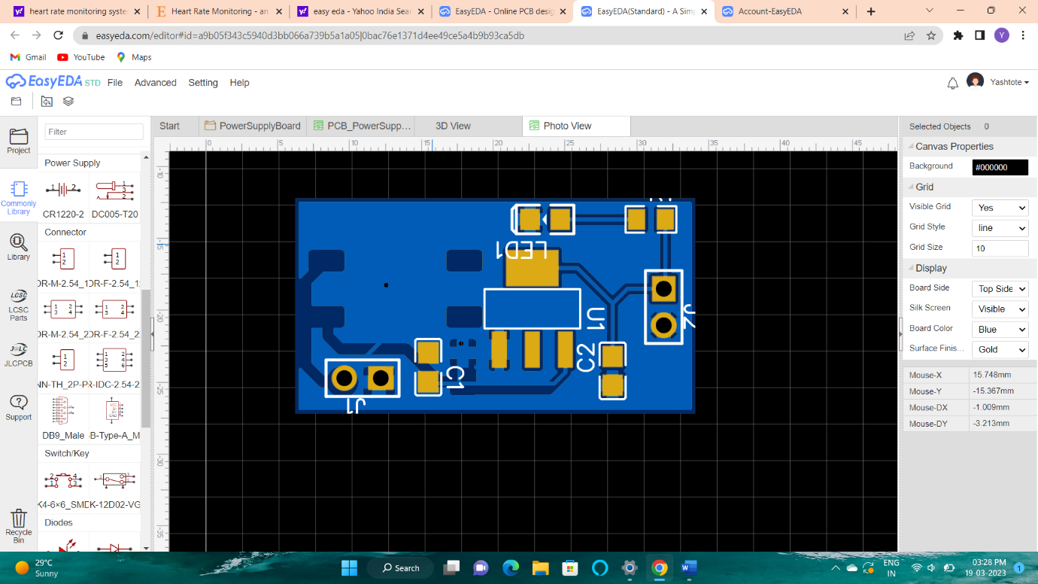

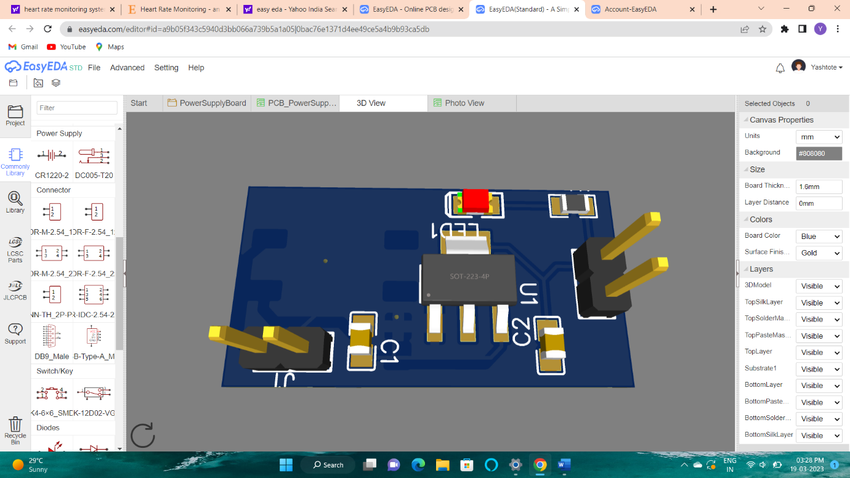

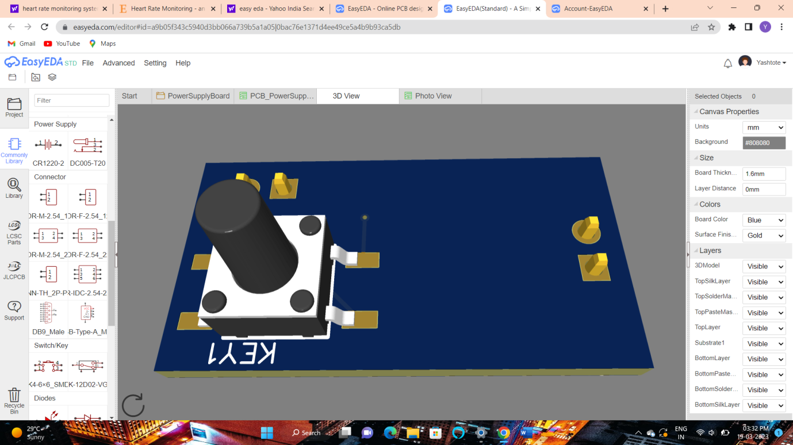

**Headdy uC board:**

**Schematic dia:**

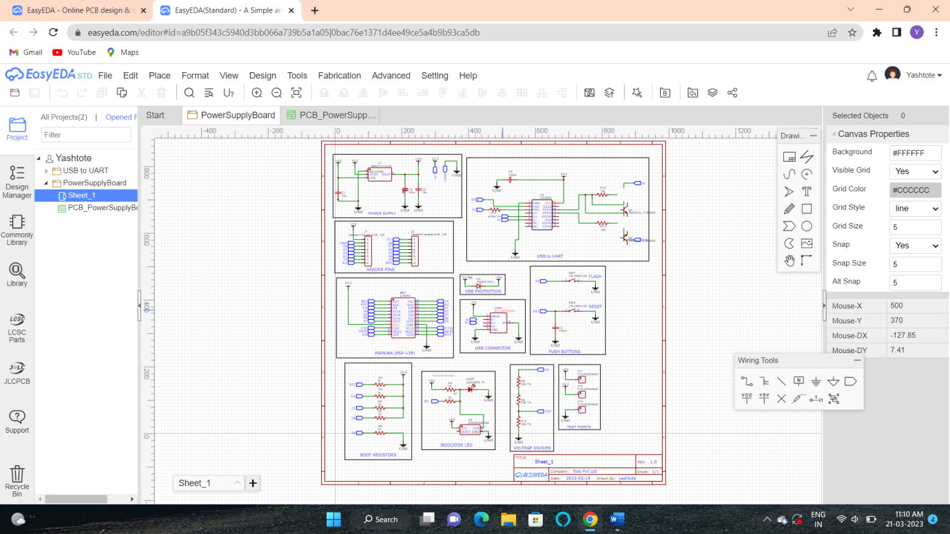

**Pcb board:**

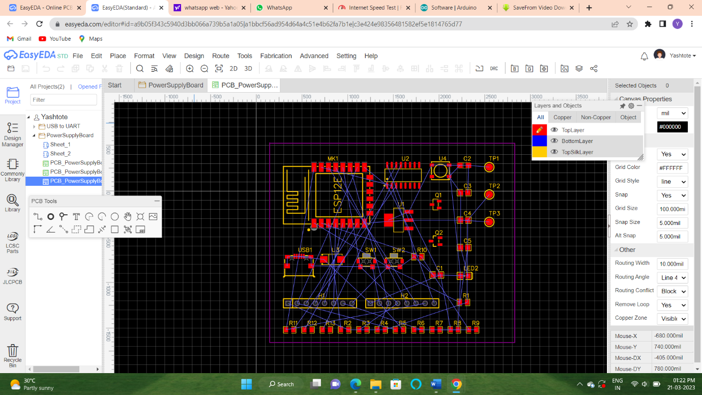

**2-D:**

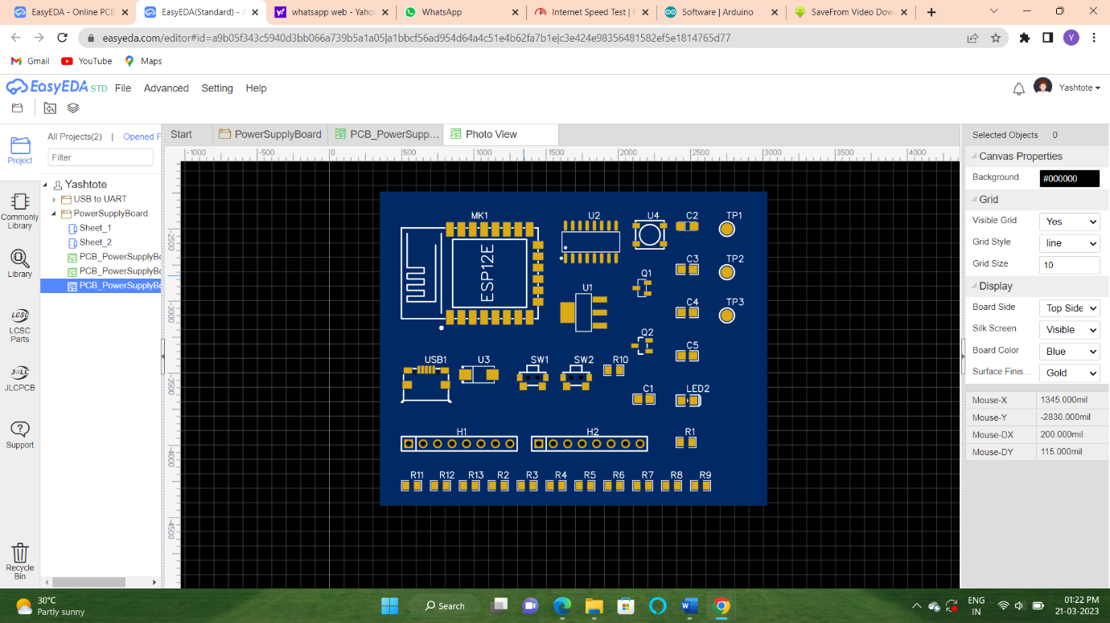

**3-D:**

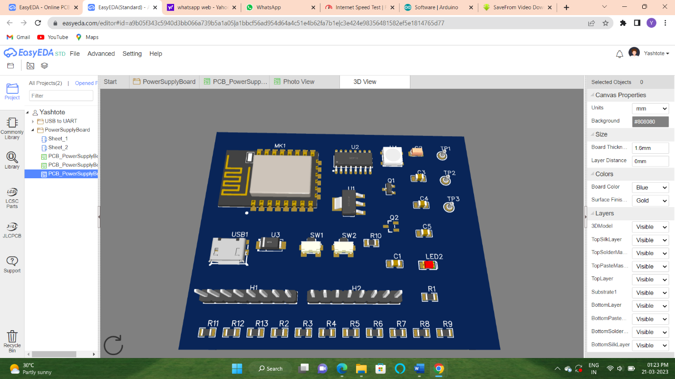

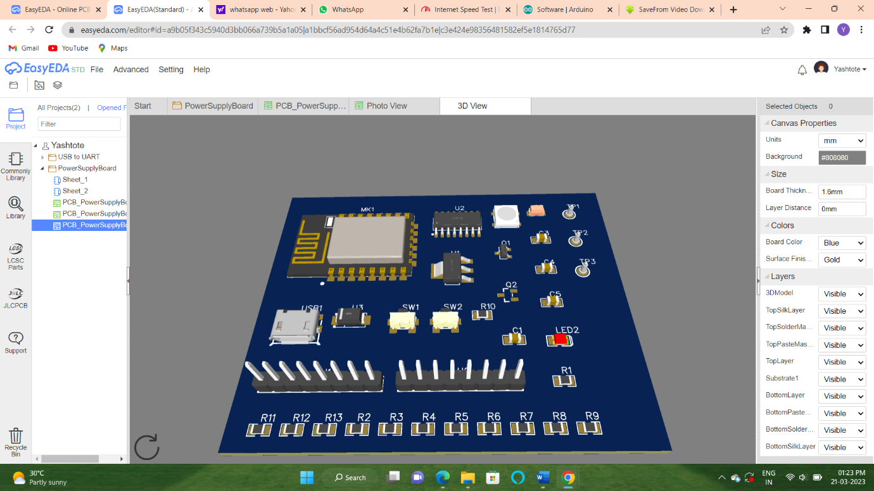

**Wirirng Tools:**

**Flags:**

Net Flag

**NetFlag** is the same as NetLabel, you can find the NetFlag from the Wiring Tools palette or using the Ctrl+G hotkeys for **GND** or Ctrl+Q for **VCC**. You can also change its name, for example from **+5V** to **VDD**:

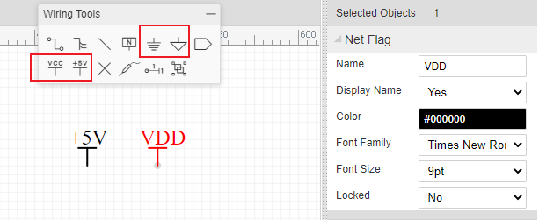

**When appear two and more Netflag or Netlabels which are the same name, they will connected with each other**.

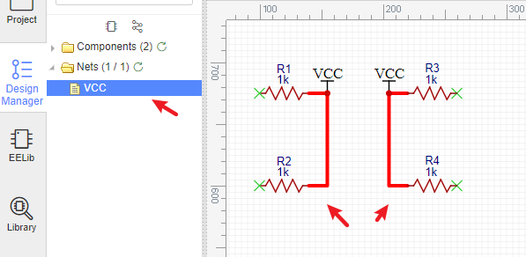

**Wiring Tools palette provides NetFlag: Digital GND, Analog GND, VCC and +5V for your convenience**.

## Net Port

**At EasyEDA, Net Port works like Net Label, it doesn’t differentiate the input and output net port. When you don’t want to route too many wires, how about trying Net Port :**

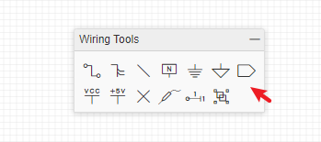

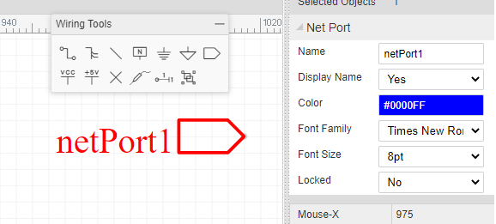

**It will make your schematic look more clean, and you just need to set each Net Port a net name.**

Wire

**There are three ways to enter the wire mode in EasyEDA.**

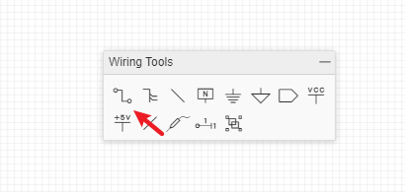

1. **Click the Wire button from the Wiring Tools palette.**
2. **Press the W hotkey.**
3. **Click on the end of a component pin (where the grey pin dot appears if you select the component):**  
   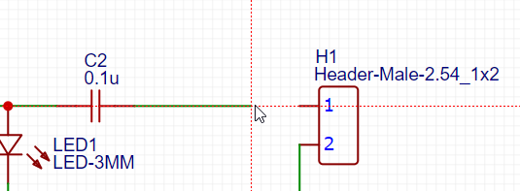

**EasyEDA automatically enters Wire mode.**

**Here is a screenshot of the Astable Multivibrator LED project schematic after wiring:**

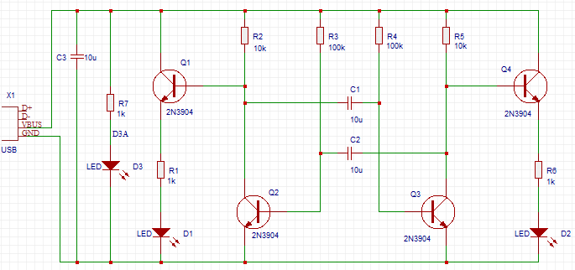

**Moving Components and Wires**:

**If you place a component, such as a resistor, on top of a wire then the wire breaks and reconnects to the ends of the component.**

**When moving selected components using the mouse, they will drag attached wires with them (“rubber band”) to some extent but please be aware that the rubber banding feature has some limitations. When moving selected components most wire will move vertically and horizontally.** **Using the arrow keys will not rubber band. Selected wires do not rubber band.**

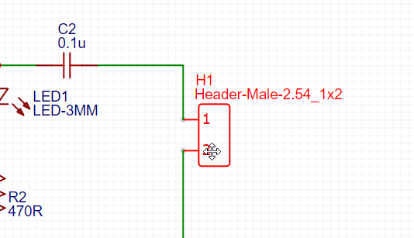

**A selected wire can be moved directly by clicking on it using the mouse or by the arrow keys. If a wire is selected by clicking on it using the mouse then green grab handles will appear at the ends and vertices.**

**Auto adjust connection**

**If you put a resistor or capacitor on a wire, the wire will auto connect the pins as below:**

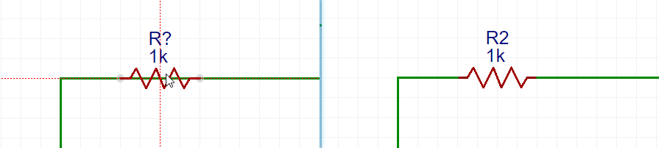

**When you want to wiring a series of resistors which are in a row, you can just wire through them, and then you will find they all be connected**.

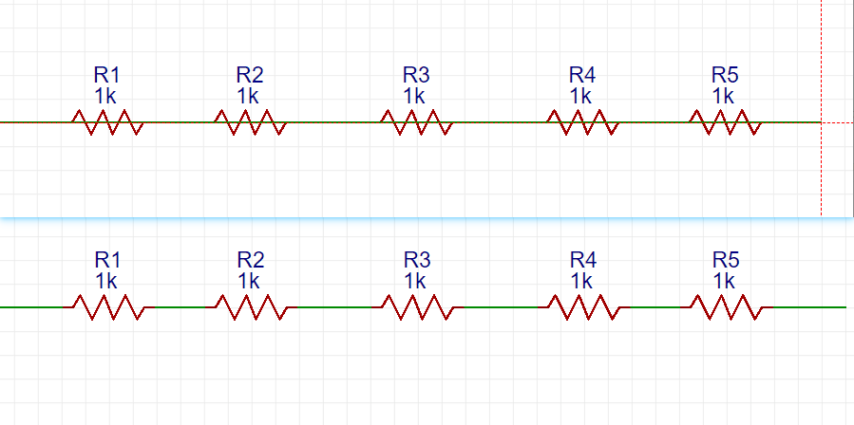

**Wire Node**

**When you click on the wire, you can see the nodes on the wire, where the white is the virtual node, the red is the real node, drag the virtual node to generate the real node, and right-delete the line segment is to delete the line segment between the real nodes.**

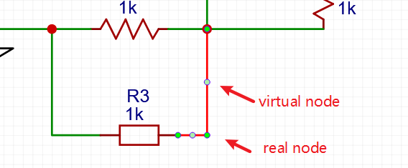

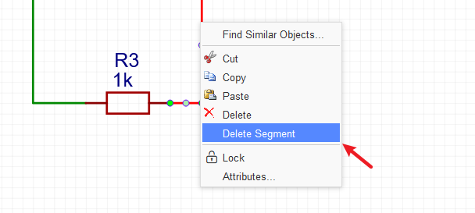

Wiring Tools:

**Content**

1. [**Wire**](https://docs.easyeda.com/en/Schematic/Wiring-Tools/index.html#Wire)
2. [**Bus**](https://docs.easyeda.com/en/Schematic/Wiring-Tools/index.html#Bus)
3. [**Bus Entry**](https://docs.easyeda.com/en/Schematic/Wiring-Tools/index.html#Bus-Entry)
4. [**Net Label**](https://docs.easyeda.com/en/Schematic/Wiring-Tools/index.html#Net-Label)
5. [**Net Flag**](https://docs.easyeda.com/en/Schematic/Wiring-Tools/index.html#Net-Flag)
6. [**Net Port**](https://docs.easyeda.com/en/Schematic/Wiring-Tools/index.html#Net-Port)
7. [**No Connect Flag**](https://docs.easyeda.com/en/Schematic/Wiring-Tools/index.html#No-Connect-Flag)
8. [**Voltage Probe**](https://docs.easyeda.com/en/Schematic/Wiring-Tools/index.html#Voltage-Probe)
9. [**Pin**](https://docs.easyeda.com/en/Schematic/Wiring-Tools/index.html#Pin)
10. [**Group/Ungroup Symbol**](https://docs.easyeda.com/en/Schematic/Wiring-Tools/index.html#Group-Ungroup-Symbol)

Drawing Tools:

**Content**

1. [**Sheet Setting**](https://docs.easyeda.com/en/Schematic/Drawing-Tools/index.html#Sheet-Setting)

[**Custom Sheet**](https://docs.easyeda.com/en/Schematic/Drawing-Tools/index.html#Custom-Sheet)

1. [**Line**](https://docs.easyeda.com/en/Schematic/Drawing-Tools/index.html#Line)
2. [**Bezier**](https://docs.easyeda.com/en/Schematic/Drawing-Tools/index.html#Bezier)
3. [**Arc**](https://docs.easyeda.com/en/Schematic/Drawing-Tools/index.html#Arc)
4. [**Arrow Head**](https://docs.easyeda.com/en/Schematic/Drawing-Tools/index.html#Arrow-Head)
5. [**Text**](https://docs.easyeda.com/en/Schematic/Drawing-Tools/index.html#Text)
6. [**Image**](https://docs.easyeda.com/en/Schematic/Drawing-Tools/index.html#Image)
7. [**Drag**](https://docs.easyeda.com/en/Schematic/Drawing-Tools/index.html#Drag)
8. [**Canvas Origin**](https://docs.easyeda.com/en/Schematic/Drawing-Tools/index.html#Canvas-Origin)

**Convert to PCB**

Most of the time, schematics are created with the aim of producing a PCB. So how do you convert your schematic to a PCB in EasyEDA? You just need to to click the PCB icon on the toolbar with the title **Convert to PCB**.

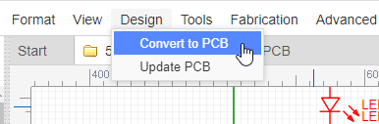

**Note**:

* *Before converting, you need to use the Design Manager and Footprint Manager to check all the components, nets(connection) and footprints to ensure no errors exist.*

**2D View**

**EasyEDA provide a nice Photo View to help you to check the PCB**.

**3D View**

**After click 3D view menu, the server will generate the 3D view file, when the editor loading finish, you will see a pretty cool 3D view.**

Component identification:

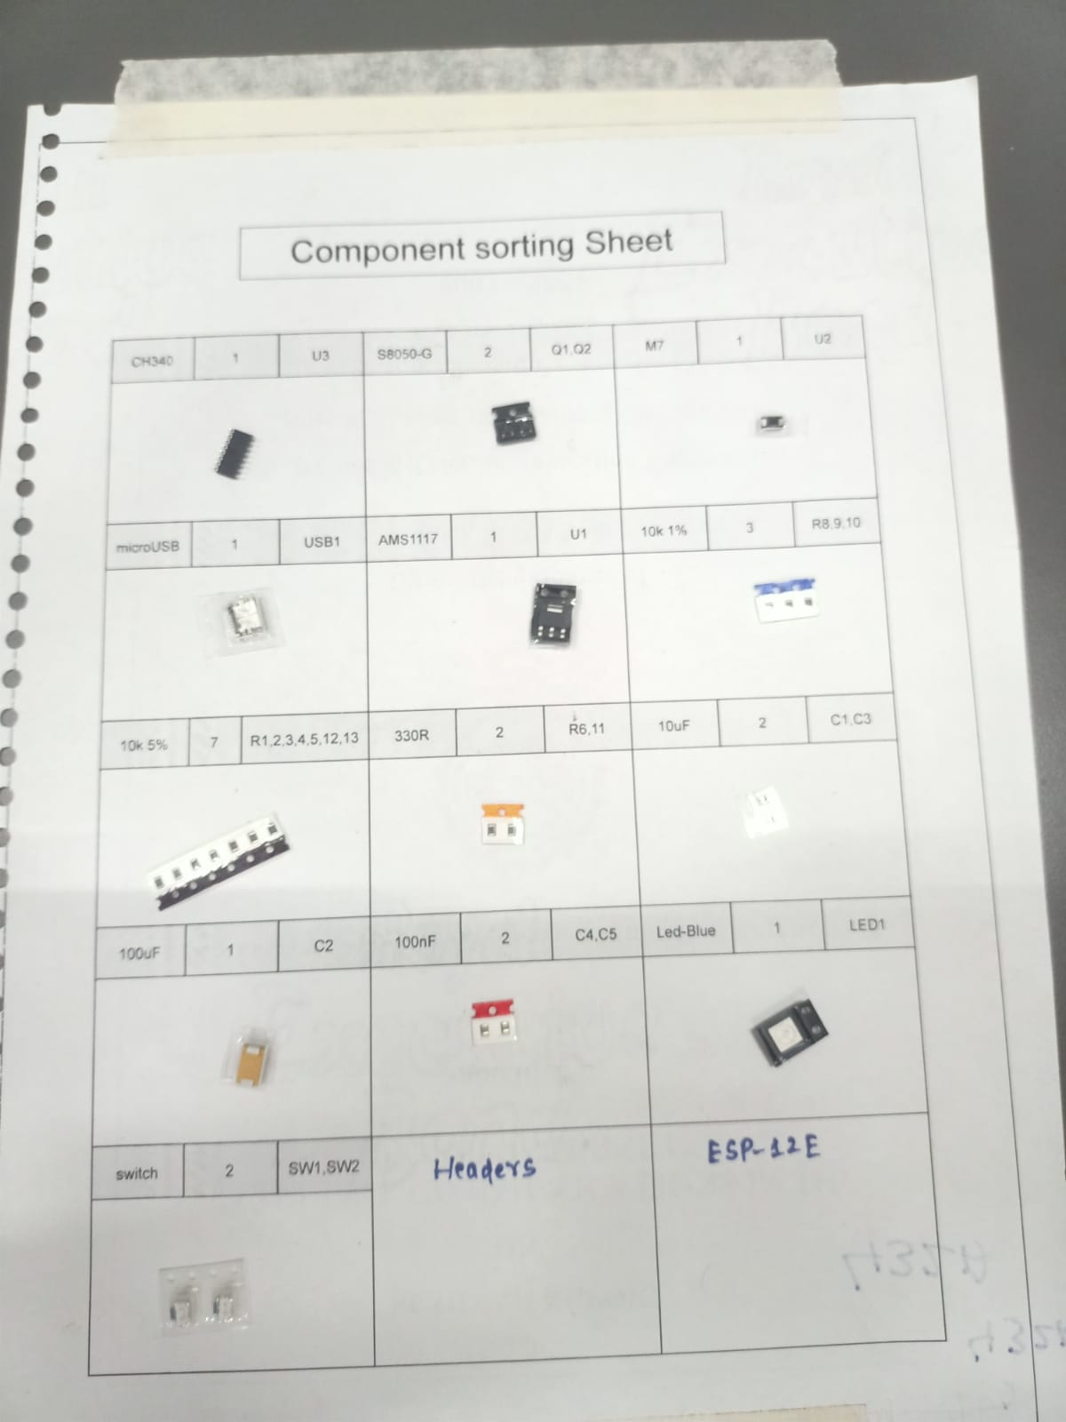

**Component Soldering:**

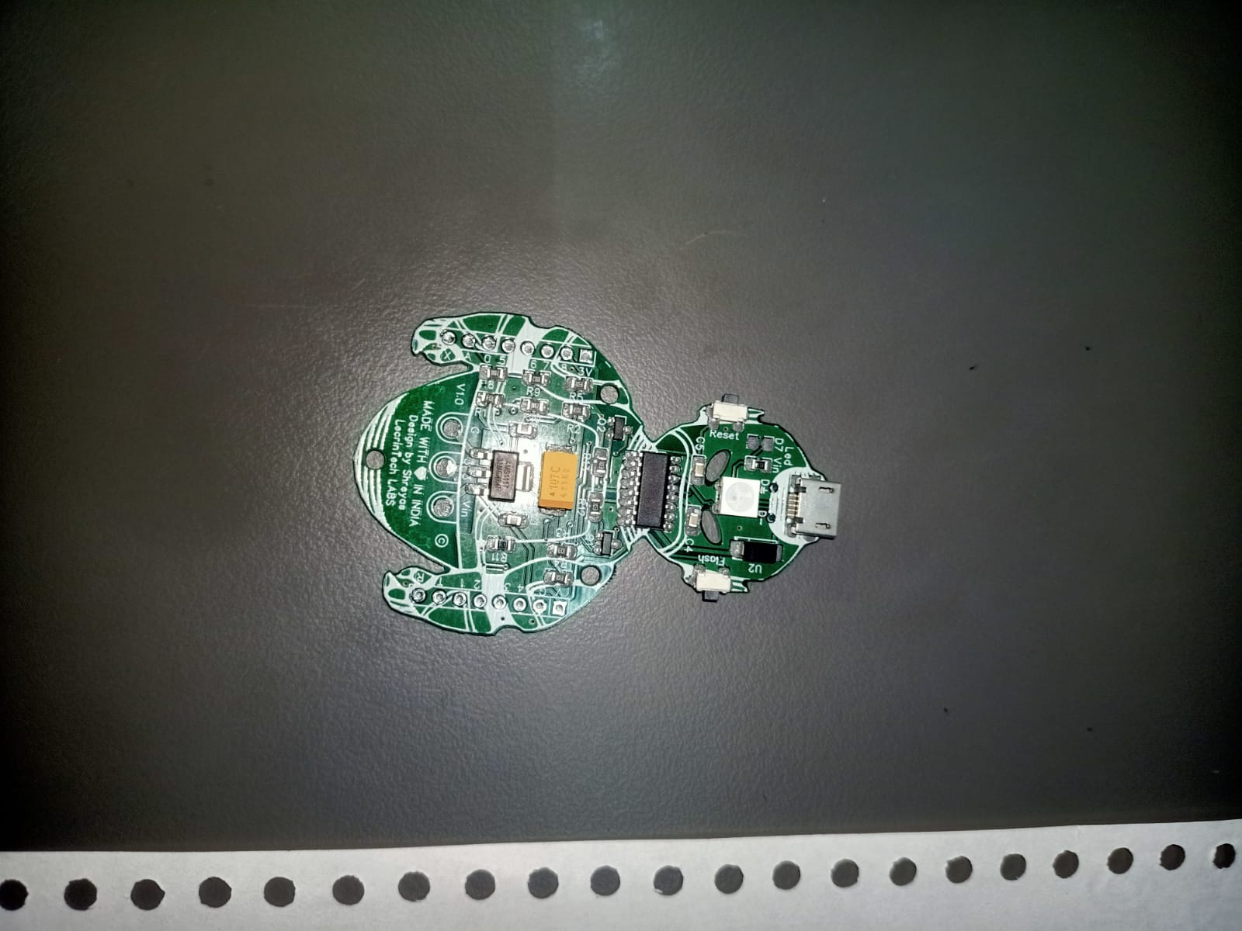

**Inputing program and troubleshooting and testing the working of board and testing using application:**

